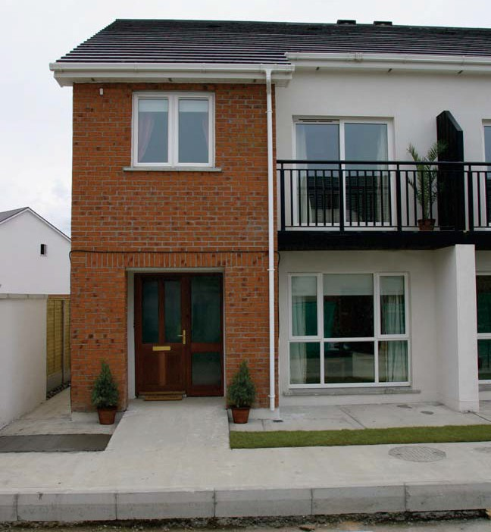
Comhshaol, Pobal agus Rialtas Áitiúil
Environment, Community and Local Government

2016 Tenant (Incremental)

Purchase Scheme

Tenant Information

February 2016
1

2016 Tenant (Incremental) Purchase Scheme

This booklet tells you about the 2016 Tenant (Incremental) Purchase Scheme for existing Local Authority houses. If you intend to apply under the Scheme, you should contact your Local Authority for more information.

2

2016 Tenant (Incremental) Purchase Scheme

Contents

- What is the 2016 Tenant (Incremental) 5
Purchase Scheme? 5
- How does the Scheme work? 5
- Can I apply? 6
- Are all Local Authority properties included
in the Scheme? 7
- Will my house be repaired or improved
before I buy it? 7
- Who will maintain my house after I buy it? 8
- Are there restrictions on the use of my
house after I buy it? 8
- How much will I pay for my house? 8
- Can I appeal the valuation of my house? 8
- Can I re-sell my house? 9
- How is my income calculated for the Scheme? 9
- Whose income is included? 9
- What discount will I get? 10

3

2016 Tenant (Incremental) Purchase Scheme

What is the incremental purchase charge? 10
- How do I finance my purchase? 14
- What is a Local Authority Home Loan? 14
- Is there a closing date for the Scheme? 15
- How do I apply? 15
- How will my Application be processed? 15

4

2016 Tenant (Incremental) Purchase Scheme

What is the Tenant (Incremental) Purchase Scheme 2016?
This is a new Scheme to let Local Authority tenants buy their homes.

How does the Scheme work?
Under this Scheme, you can apply to your Local Authority to buy your local authority house. If approved, you must continue to live in the house for as long as you own it.
You will get a discount on the price of the house based on your income.
Your Local Authority will also place a charge on your house called an ‘incremental purchase charge’. This charge will be equal to the discount you get on the price of the house. The charge will remain in place for 20, 25 or 30 years (depending on the discount given). Each year, the local authority will reduce the charge by 2%. At the end of the 20, 25 or 30 years, the charge will be zero as long as you obey the terms and conditions of the scheme.
You will be able to resell your house at any time if your Local Authority agrees. However, if you sell before the end of the 20, 25 or 30 years, you will have to pay back the value of the outstanding charge on your house to your Local Authority.
See sections 13 and 14 for more information about the discount and charge, and examples of how they work.

5

2016 Tenant (Incremental) Purchase Scheme

Can I apply?
You can apply for the scheme if you meet the following conditions:
- Social housing support – you must have been getting social housing support for at least ten years. In the case of joint tenants, both tenants must be in receipt of social housing support for at least ten years.

- Income – you must have an annual income of at least €12,500 (see section 11 for more details);

- Anti-social behaviour – no-one living in your house can be engaged in anti-social behaviour (this will be checked with the Gardaí);

- Arrears – you must not have been behind in your rent or local authority charges for more than 12 weeks in the past three years. If you were, you must have made a payment arrangement with your local authority and be following that arrangement;

- Previous ownership – you must not have bought a house under an earlier Tenant Purchase Scheme;

- Water charges – you must have paid your water charges.

6

2016 Tenant (Incremental) Purchase Scheme

Are all Local Authority properties included in the Scheme?
No. The following types of properties are not included:
- apartments, flats, maisonettes and duplexes;
- houses specially designed for older people;
- houses provided for people with disabilities to help them leave institutional care and live in the community;
- houses that are part of a group housing scheme for Travellers;
- caravans, mobile homes or other homes that can be moved;
- houses in a private development transferred to the Local Authority by the Developer;
- houses reserved by the Local Authority for particular reasons.

Your Local Authority can tell you if your type of property is included in the scheme.

Will my house be repaired or improved before I buy it?
No. The market value (price) of your house will reflect its existing condition. The Local Authority will give no guarantees as to the state of repair or structural condition of the house.

7

2016 Tenant (Incremental) Purchase Scheme

Who will maintain my house after I buy it?
You will. Like all homeowners, you will be responsible for maintaining and carrying out repairs on your house from the date you buy it. You will also have to get and keep adequate property insurance on your house – and pay for this yourself. As the owner of the house, you will be responsible for the payment of the local property tax for the house.

Are there restrictions on the use of my house after I buy it?
Yes. You must:
- live in the house as your normal place of residence;
- get agreement from your Local Authority if you want to sell, let or sub-let the house; and
- not engage in anti-social behaviour or be a
nuisance to your neighbours.

How much will I pay for my house?
You will pay the market value of the house – less a discount. Either the local authority or a qualified valuer acting on behalf of the local authority will decide the market value

Can I appeal the valuation of my house?
If you do not agree with the Local Authority’s valuation of your house, you may hire an independent valuer from a panel of valuers set up by your Local Authority. You must pay the cost of this independent valuation yourself.

8

Tenants (Incremental) Purchase Scheme
February 2016

Can I re-sell my house?
Yes. You can re-sell your house at any time.
However, if you re-sell your house while the incremental purchase charge is in place, you will have to get the written agreement of your Local Authority. You will also have to pay the current value of the outstanding incremental purchase charge to your Local Authority. See Section 14 for more details on this.
Your Local Authority will have first option to buy back your house while the incremental purchase charge is in place.

How is my income calculated for the scheme?
Your Local Authority will calculate your gross income (that is, your income before deduction of income tax, Universal Social Charge, pension contributions, pension- related deductions and PRSI). This includes income from wages, salaries, and some social welfare payments but only where they are additional to employment income. It does not include Child Benefit, Carer’s Allowance or Family Income Supplement.

Whose income is included?
The only income included will be that of the tenants of the house and the spouse, civil partner or other partner (cohabitant) who lives in the house with them.

9

2016 Tenant (Incremental) Purchase Scheme

What discount will I get?
Depending on your gross annual income, the discounts will vary between 40% and 60%. The discount will be given against the market value (purchase price) of your house.

Gross annual income | Discount
Between €12,500 and €20,000 | 60%
Between €20,001 and €29,999 | 50%
€30,000 or more | 40%

Example:
If your Local Authority house is valued at €150,000 and your gross annual income is €18,000, you will get a discount of 60% against the purchase price. This means you will pay €60,000 for the house (40% of €150,000 is
€60,000).
However, the Local Authority will place an incremental purchase charge on the house equal to the discount you get.

What is the incremental purchase charge?
One of the conditions of the sale is that your local authority will place an incremental purchase charge on the house equal to the value of the discount you get.
This charge will reduce to zero over 20, 25 or 30 years (called the ‘charge period’), as long as you obey the conditions of the sale under the scheme.

10

2016 Tenant (Incremental) Purchase Scheme

You will have to pay back the value of the outstanding charge to the Local Authority if:
- you sell the house before the end of the charge period; or
- your incremental purchase charge is not reduced for one or more years because you did not obey the conditions of the scheme. It remains due for repayment at the end of the charge period.
The period of the incremental purchase charge will depend on the discount. For example, if you get a discount of 50% based on your gross annual income (see section 13), the charge period will be 25 years.

Discount | Charge Period
60% | 30 years
50% | 25 years
40% | 20 years

11

2016 Tenant (Incremental) Purchase Scheme

Here are two examples of how the scheme works.

Example 1:
You buy your house and keep it for the full charge period

Purchase price (market value) at date of sale: | €150,000
Discount: | 50% [based on your income]
Purchase money (price actually paid): | €75,000
Incremental purchase charge on house: | 50% of value of house
Charge period: | 25 years [based on discount]
Each year, the incremental purchase charge will drop by 2% of the value of the house. After 25 years, the charge will be zero.

12

Example 2:
2016 Tenant (Incremental) Purchase Scheme

You buy your house and re-sell it after 10 years

Purchase price (market value) at date of sale: | €150,000
Discount: | 50% [based on your income]
Purchase money (price actually paid): | €75,000
Incremental purchase charge on house: | 50% of value of house
Charge period: | 25 years [based on discount]
Resale of house after 10years:
Market value of house on resale: | €160,000
Outstanding incremental purchase charge: | 30%  [50% less 20% = 30%]*
Pay back to local authority to clear charge:* | €48,000  [€160,000 x 30% =  €48,000]

* The original incremental purchase charge was 50% but each year it has reduced by 2%. So, over the 10 years, the charge has fallen by 20% (2% x 10 = 20%). This means you only have to pay back 30% (€48,000) of the current market value.

13

2016 Tenant (Incremental) Purchase Scheme

How do I finance my purchase?
You will have to pay the purchase money in full at the time the house purchase is completed. You will be responsible for raising the money to do this (for example, from savings, a mortgage loan, and so on). You must meet the Local Authority’s requirements in relation to how you are going to pay for the house.
If you can afford it, you can buy your house without a mortgage loan as long as you meet all the eligibility criteria (see Section 3). This includes having a gross annual income of at least €12,500. You must have this income so that you can maintain your house during the charge period.
You may be able to apply to your Local Authority for a Local Authority Home Loan. See Section 16 for more details. You will have to pay all your costs, including legal fees, to complete the purchase of your Local Authority house.

What is a Local Authority Home Loan?
This is a mortgage loan available from your Local Authority. To apply for this loan, you must be:
- aged between 18 and 70 years;
- earning less than €65,000 (gross)in the previous tax year as a single Applicant or less than €75,000 as Joint Applicants;
- in continuous employment (or self-employment) for at least two years if you are the primary earner on

14

2016 Tenant (Incremental) Purchase Scheme

the Application. If this is a Joint Application, your spouse or partner must have been in continuous employment for at least one year (if you are relying on their income to help repay the mortgage).

You must fill out a Local Authority Home Loan Application Form which you can get from your Local Authority and provide the support Documents needed to assess your ability to borrow.

This Application is separate from your Application for the 2016 Tenant (Incremental) Purchase Scheme.

Is there a closing date for the Scheme?
No, there is no closing date for applying to the Scheme. This gives you time to examine the details of the Scheme before making a decision.

How do I apply?
- You must fill out a 2016 Tenant (Incremental) Purchase Scheme Application Form which you can get from your Local Authority.
- You must give proof of your income.
- You must show your Local Authority how you intend to pay for the house.
- You must give the Local Authority any other information it asks for about your Application.

How will my Application be processed?
This may vary slightly from one Local Authority to the next but, in general, your Application will be processed in five stages:

15

2016 Tenant (Incremental) Purchase Scheme

Stage 1 – income and tenancy eligibility
Your Local Authority will assess your Application to make sure it follows the rules about income and tenancy (see Section 3). It is important to give all the support Documents asked for. This is to make sure your Application is acceptable. Support documents include Employment Detail Summary (previously known as P60), payslips, salary certificates, and so on. If your local authority asks for more information, you must supply it within four weeks. If you do not qualify for the scheme, your local authority will write and tell you.

Stage 2 – property valuation
A professional valuer, nominated by your local authority, will visit your house to assess its value.

Stage 3 – letter of offer giving market value, discount and price
Your Local Authority will send you a ‘letter of offer’, outlining:
- the market value (purchase price) of the house;
- the discount you may get under the Scheme;
- the price you must pay to complete the purchase; and
- the terms and conditions regarding the sale.
The offer will last for a set time. After that, the market value, discount and price you must pay may change.

16

2016 Tenant (Incremental) Purchase Scheme

Stage 4 – accepting the offer and confirming purchase funding
If you are happy to accept the offer and go ahead with the purchase, you will have to supply evidence (such as a bank statement of savings or a letter of loan offer from your lender) to show that you have the money to complete the purchase. The legal transfer of your Local Authority house will start only when this stage has been completed.

Stage 5 – completion of purchase and transfer of ownership
When you have paid the purchase price in full, the legal transfer of the house will be completed and you will become the owner. The Local Authority is not obliged to transfer the property to you until all stages of the application process have been completed.
For more information about the Scheme, please contact your Local Authority.

17

